SQL | DDL, DML, TCL and DCL
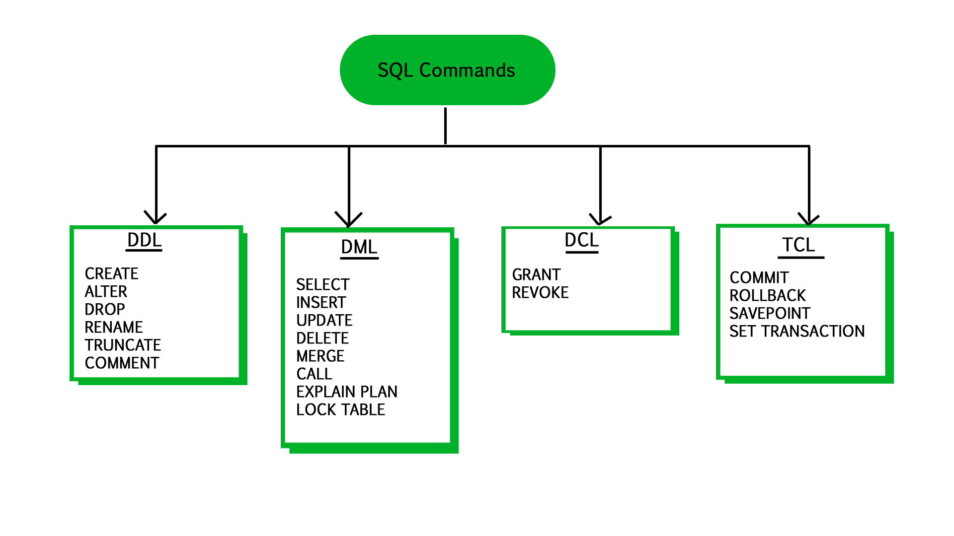

TCL (Transaction Control Language) :

Transaction Control Language commands are used to manage transactions in the database. These are used to manage the changes made by DML-statements.
COMMIT: Commit command is used to permanently save any transaction
into the database.
ROLLBACK: This command restores the database to last committed state.
It is also used with savepoint command to jump to a savepoint in a transaction.
SAVEPOINT: Savepoint command is used to temporarily save a transaction so that you can rollback to that point whenever necessary.

DCL (Data Control Language) :
A Data Control Language is a syntax similar to a computer programming language used to control access to data stored in a database (Authorization). In particular, it is a component of Structured Query Language (SQL).

GRANT: allow specified users to perform specified tasks.
REVOKE: cancel previously granted or denied permissions.

SQL | TRANSACTIONS

What are Transactions?
Transactions group a set of tasks into a single execution unit. Each transaction begins with a specific task and ends when all the tasks in the group successfully complete. If any of the tasks fail, the transaction fails. Therefore, a transaction has only two results: success or failure.
Incomplete steps result in the failure of the transaction. A database transaction, by definition, must be atomic, consistent, isolated and durable. These are popularly known as
ACID properties.
How to implement Transactions using SQL?
Following commands are used to control transactions. It is important to note that these statements cannot be used while creating tables and are only used with the DML Commands such as – INSERT, UPDATE and DELETE.
1. BEGIN TRANSACTION: It indicates the start point of an explicit or local transaction.
Syntax:
BEGIN TRANSACTION transaction_name ;
2. SET TRANSACTION: Places a name on a transaction.
Syntax: SET TRANSACTION [ READ WRITE | READ ONLY ];
3. COMMIT: If everything is in order with all statements within a single transaction, all changes are recorded together in the database is called committed.The COMMIT command saves all the transactions to the database since the last COMMIT or ROLLBACK command.
Syntax: COMMIT;
Example: Sample table 1
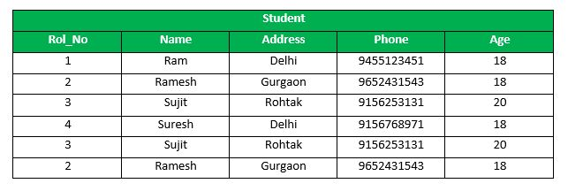
Following is an example which would delete those records from the table which have age = 20 and then COMMIT the changes in the database.
Queries:
DELETE FROM Student WHERE AGE = 20;
COMMIT;
Output:
Thus, two rows from the table would be deleted and the SELECT statement would look like,
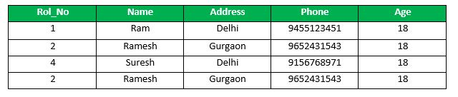

4. ROLLBACK: If any error occurs with any of the SQL grouped statements, all changes need to be aborted. The process of reversing changes is called rollback.This command can only be used to undo transactions since the last COMMIT or ROLLBACK command was issued.
Syntax: ROLLBACK;
Example:
From the above example Sample table1,
Delete those records from the table which have age = 20 and then ROLLBACK the changes in the database.
Queries:
DELETE FROM Student WHERE AGE = 20;
ROLLBACK;
Output:
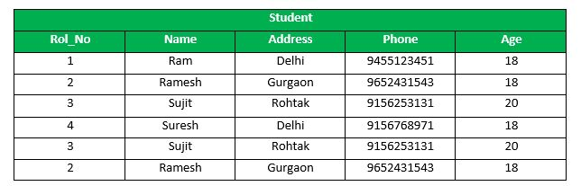
5. SAVEPOINT: creates points within the groups of transactions in which to ROLLBACK.
A SAVEPOINT is a point in a transaction in which you can roll the transaction back to a certain point without rolling back the entire transaction.
Syntax for Savepoint command: SAVEPOINT SAVEPOINT_NAME;
This command is used only in the creation of SAVEPOINT among all the transactions.
In general ROLLBACK is used to undo a group of transactions.
Syntax for rolling back to Savepoint command:
ROLLBACK TO SAVEPOINT_NAME;
you can ROLLBACK to any SAVEPOINT at any time to return the appropriate data to its original state.
Example:
From the above example Sample table1,
Delete those records from the table which have age = 20 and then ROLLBACK the changes in the database by keeping Savepoints.
Queries:
SAVEPOINT SP1; //Savepoint created.
DELETE FROM Student WHERE AGE = 20; //deleted
SAVEPOINT SP2; //Savepoint created.
Here SP1 is first SAVEPOINT created before deletion.In this example one deletion have taken place.
After deletion again SAVEPOINT SP2 is created.
Output:
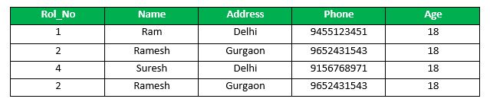
Deletion have been taken place, let us assume that you have changed your mind and decided to ROLLBACK to the SAVEPOINT that you identified as SP1 which is before deletion.
deletion is undone by this statement ,
ROLLBACK TO SP1;
//Rollback completed.
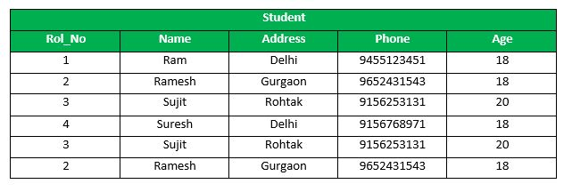

6. RELEASE SAVEPOINT:-This command is used to remove a SAVEPOINT that you have created.
Syntax: RELEASE SAVEPOINT SAVEPOINT_NAME
Once a SAVEPOINT has been released, you can no longer use the ROLLBACK command to undo transactions performed since the last SAVEPOINT.
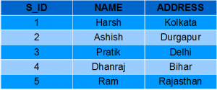
SQL | Views

Views in SQL are kind of virtual tables. A view also has rows and columns as they are in a real table in the database. We can create a view by selecting fields from one or more tables present in the database. A View can either have all the rows of a table or specific rows based on certain condition.
In this article we will learn about creating , deleting and updating Views.
Sample Tables
StudentDetails

StudentMarks
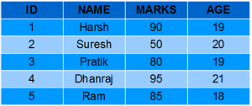
CREATING VIEWS
We can create View using CREATE VIEW statement. A View can be created from a single table or multiple tables.

Syntax:
CREATE VIEW view_name AS SELECT column1, column2.....FROM table_name WHERE condition;
Examples:
- Creating View from a single table:
Query:
CREATE VIEW DetailsView AS SELECT NAME, ADDRESS
FROM StudentDetails WHERE S_ID < 5;
SELECT * FROM DetailsView;

  - Output: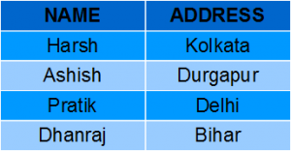
  - In this example, we will create a view named StudentNames from the table StudentDetails.
Query:
  - CREATE VIEW StudentNames AS SELECT S_ID, NAME FROM StudentDetails ORDER BY NAME;
If we now query the view as,
SELECT * FROM StudentNames;
Output:
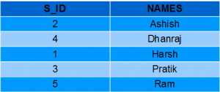
- Creating View from multiple tables:
- Query:
CREATE VIEW MarksView AS SELECT StudentDetails.NAME, StudentDetails.ADDRESS, StudentMarks.MARKS FROM StudentDetails, StudentMarks WHERE StudentDetails.NAME = StudentMarks.NAME;
To display data of View MarksView:
SELECT * FROM MarksView;
Output:
- 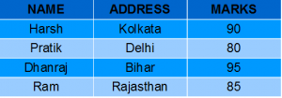
DELETING VIEWS
Syntax: DROP VIEW view_name;

For example, if we want to delete the View MarksView, we can do this as:
DROP VIEW MarksView;
UPDATING VIEWS
There are certain conditions needed to be satisfied to update a view. If any one of these conditions is not met, then we will not be allowed to update the view.
- The SELECT statement which is used to create the view should not include GROUP BY clause or ORDER BY clause.
- The SELECT statement should not have the DISTINCT keyword.
- The View should have all NOT NULL values.
- The view should not be created using nested queries or complex queries.
- The view should be created from a single table. If the view is created using multiple tables then we will not be allowed to update the view.
- We can use the CREATE OR REPLACE VIEWstatement to add or remove fields from a view.
Syntax:
CREATE OR REPLACE VIEW view_name AS SELECT column1,coulmn2,..
FROM table_name WHERE condition;

SELECT StudentDetails.NAME, StudentDetails.ADDRESS, StudentMarks.MARKS, StudentMarks.AGE
FROM StudentDetails, StudentMarks
WHERE StudentDetails.NAME = StudentMarks.NAME;
If we fetch all the data from MarksView now as:
SELECT * FROM MarksView;
Output: 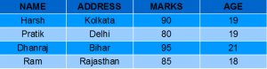
- Inserting a row in a view:
INSERT INTO view_name(column1, column2 , column3,..)
VALUES(value1, value2, value3..);
ex;
INSERT INTO DetailsView(NAME, ADDRESS) VALUES("Suresh","Gurgaon");
If we fetch all the data from DetailsView now as,
SELECT * FROM DetailsView;
Output:
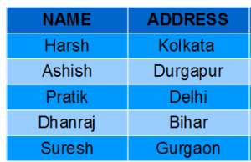
- Deleting a row from a View:
Deleting rows from a view is also as simple as deleting rows from a table. We can use the DELETE statement of SQL to delete rows from a view. Also deleting a row from a view first delete the row from the actual table and the change is then reflected in the view.Syntax:
DELETE FROM view_name
WHERE condition;

view_name:Name of view from where we want to delete rows
condition: Condition to select rows
Example:
In this example we will delete the last row from the view DetailsView which we just added in the above example of inserting rows.
DELETE FROM DetailsView
WHERE NAME="Suresh";
If we fetch all the data from DetailsView now as,
SELECT * FROM DetailsView;
Output:
WITH CHECK OPTION
The WITH CHECK OPTION clause in SQL is a very useful clause for views. It is applicable to a updatable view. If the view is not updatable, then there is no meaning of including this clause in the CREATE VIEW statement.
- The WITH CHECK OPTION clause is used to prevent the insertion of rows in the view where the condition in the WHERE clause in CREATE VIEW statement is not satisfied.
- If we have used the WITH CHECK OPTION clause in the CREATE VIEW statement, and if the UPDATE or INSERT clause does not satisfy the conditions then they will return an error.
Example:
In the below example we are creating a View SampleView from StudentDetails Table with WITH CHECK OPTION clause.
CREATE VIEW SampleView AS
SELECT S_ID, NAME
FROM StudentDetails
WHERE NAME IS NOT NULL
WITH CHECK OPTION;
In this View if we now try to insert a new row with null value in the NAME column then it will give an error because the view is created with the condition for NAME column as NOT NULL.
For example,though the View is updatable but then also the below query for this View is not valid:
INSERT INTO SampleView(S_ID)
VALUES(6);
NOTE: The default value of NAME column is null.
Uses of a View :
A good database should contain views due to the given reasons:
- Restricting data access –
Views provide an additional level of table security by restricting access to a predetermined set of rows and columns of a table.
- Hiding data complexity –
A view can hide the complexity that exists in a multiple table join.
- Simplify commands for the user –
Views allows the user to select information from multiple tables without requiring the users to actually know how to perform a join.
- Store complex queries –
Views can be used to store complex queries.
- Rename Columns –
Views can also be used to rename the columns without affecting the base tables provided the number of columns in view must match the number of columns specified in select statement. Thus, renaming helps to to hide the names of the columns of the base tables.
- Multiple view facility –
Different views can be created on the same table for different users.

SQL | Constraints

Constraints are the rules that we can apply on the type of data in a table. That is, we can specify the limit on the type of data that can be stored in a particular column in a table using constraints.
The available constraints in SQL are:
- NOT NULL: This constraint tells that we cannot store a null value in a column. That is, if a column is specified as NOT NULL then we will not be able to store null in this particular column any more.
- UNIQUE: This constraint when specified with a column, tells that all the values in the column must be unique. That is, the values in any row of a column must not be repeated.
- PRIMARY KEY: A primary key is a field which can uniquely identify each row in a table. And this constraint is used to specify a field in a table as primary key.
- FOREIGN KEY: A Foreign key is a field which can uniquely identify each row in a another table. And this constraint is used to specify a field as Foreign key.
- CHECK: This constraint helps to validate the values of a column to meet a particular condition. That is, it helps to ensure that the value stored in a column meets a specific condition.
- DEFAULT: This constraint specifies a default value for the column when no value is specified by the user.

SQL Stored Procedures

What is a Stored Procedure?
A stored procedure is a prepared SQL code that you can save, so the code can be reused over and over again.
So if you have an SQL query that you write over and over again, save it as a stored procedure, and then just call it to execute it.
You can also pass parameters to a stored procedure, so that the stored procedure can act based on the parameter value(s) that is passed.

Stored Procedure Syntax
CREATE PROCEDURE procedure_name
AS
sql_statement
GO;

Execute a Stored Procedure
EXEC procedure_name;

Demo Database
Below is a selection from the "Customers" table in the Northwind sample database:
CustomerID | CustomerName | ContactName | Address | City | PostalCode | Country
1 | Alfreds Futterkiste | Maria Anders | Obere Str. 57 | Berlin | 12209 | Germany
2 | Ana Trujillo Emparedados y helados | Ana Trujillo | Avda. de la Constitución 2222 | México D.F. | 05021 | Mexico
3 | Antonio Moreno Taquería | Antonio Moreno | Mataderos 2312 | México D.F. | 05023 | Mexico
4 | Around the Horn | Thomas Hardy | 120 Hanover Sq. | London | WA1 1DP | UK
5 | Berglunds snabbköp | Christina Berglund | Berguvsvägen 8 | Luleå | S-958 22 | Sweden

Stored Procedure Example
The following SQL statement creates a stored procedure named "SelectAllCustomers" that selects all records from the "Customers" table:

Example
CREATE PROCEDURE SelectAllCustomers
AS
SELECT * FROM Customers
GO;
Execute the stored procedure above as follows:

Example
EXEC SelectAllCustomers;

Stored Procedure With One Parameter
The following SQL statement creates a stored procedure that selects Customers from a particular City from the "Customers" table:

Example
CREATE PROCEDURE SelectAllCustomers @City nvarchar(30)
AS
SELECT * FROM Customers WHERE City = @City
GO;
Execute the stored procedure above as follows:

Example
EXEC SelectAllCustomers @City = 'London';

Stored Procedure With Multiple Parameters
Setting up multiple parameters is very easy. Just list each parameter and the data type separated by a comma as shown below.
The following SQL statement creates a stored procedure that selects Customers from a particular City with a particular PostalCode from the "Customers" table:

Example
CREATE PROCEDURE SelectAllCustomers @City nvarchar(30), @PostalCode nvarchar(10)
AS
SELECT * FROM Customers WHERE City = @City AND PostalCode = @PostalCode
GO;
Execute the stored procedure above as follows:

Example
EXEC SelectAllCustomers @City = 'London', @PostalCode = 'WA1 1DP';
SQL Trigger | Student Database

Trigger: A trigger is a stored procedure in database which automatically invokes whenever a special event in the database occurs. For example, a trigger can be invoked when a row is inserted into a specified table or when certain table columns are being updated.
Syntax:
create trigger [trigger_name] [before | after] {insert | update | delete} on [table_name] [for each row] [trigger_body]
Explanation of syntax:
- create trigger [trigger_name]: Creates or replaces an existing trigger with the trigger_name.
- [before | after]: This specifies when the trigger will be executed.
- {insert | update | delete}: This specifies the DML operation.
- on [table_name]: This specifies the name of the table associated with the trigger.
- [for each row]: This specifies a row-level trigger, i.e., the trigger will be executed for each row being affected.
- [trigger_body]: This provides the operation to be performed as trigger is fired
BEFORE and AFTER of Trigger:
BEFORE triggers run the trigger action before the triggering statement is run.
AFTER triggers run the trigger action after the triggering statement is run.
Example:
Given Student Report Database, in which student marks assessment is recorded. In such schema, create a trigger so that the total and average of specified marks is automatically inserted whenever a record is insert.

Here, as trigger will invoke before record is inserted so, BEFORE Tag can be used.
Suppose the database Schema –
mysql> desc Student;
+-------+-------------+------+-----+---------+----------------+
| Field | Type | Null | Key | Default | Extra |
+-------+-------------+------+-----+---------+----------------+
| tid | int(4) | NO | PRI | NULL | auto_increment |
| name | varchar(30) | YES | | NULL | |
| subj1 | int(2) | YES | | NULL | |
| subj2 | int(2) | YES | | NULL | |
| subj3 | int(2) | YES | | NULL | |
| total | int(3) | YES | | NULL | |
| per | int(3) | YES | | NULL | |
+-------+-------------+------+-----+---------+----------------+
7 rows in set (0.00 sec)
SQL Trigger to problem statement.
create trigger stud_marks
before INSERT
on
Student
for each row
set Student.total = Student.subj1 + Student.subj2 + Student.subj3, Student.per = Student.total * 60 / 100;
Above SQL statement will create a trigger in the student database in which whenever subjects marks are entered, before inserting this data into the database, trigger will compute those two values and insert with the entered values. i.e.,
mysql> insert into Student values(0, "ABCDE", 20, 20, 20, 0, 0);
Query OK, 1 row affected (0.09 sec)

mysql> select * from Student;
+-----+-------+-------+-------+-------+-------+------+
| tid | name | subj1 | subj2 | subj3 | total | per |
+-----+-------+-------+-------+-------+-------+------+
| 100 | ABCDE | 20 | 20 | 20 | 60 | 36 |
+-----+-------+-------+-------+-------+-------+------+
1 row in set (0.00 sec)

